HOME BREW D-STAR

Digital Voice Transceiver Project
By AE4JY

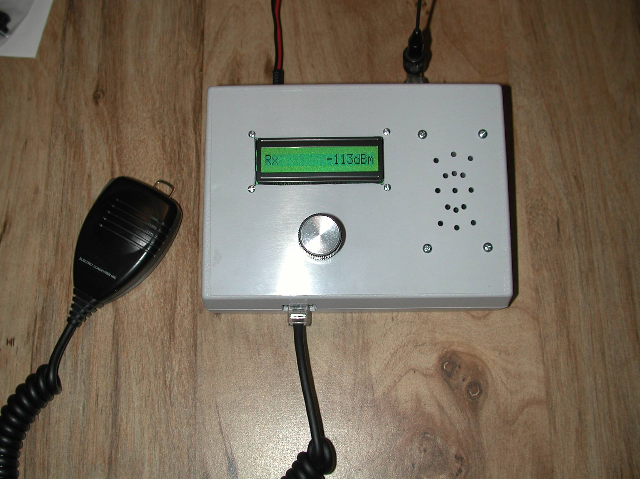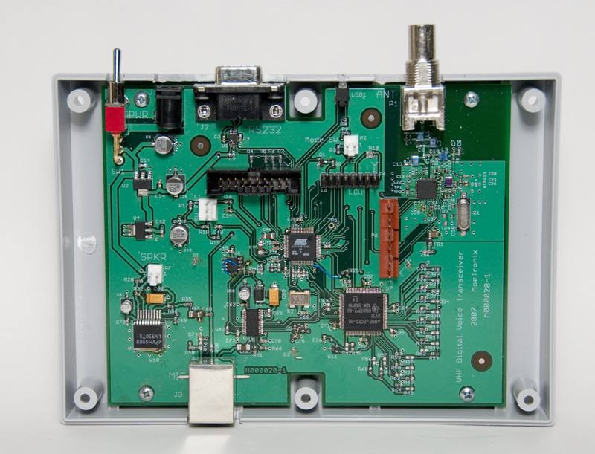

http://www.moetronix.com/dstar/

A paper on this project was presented at the SVHFS Conference in Atlanta on April 28, 2007.

